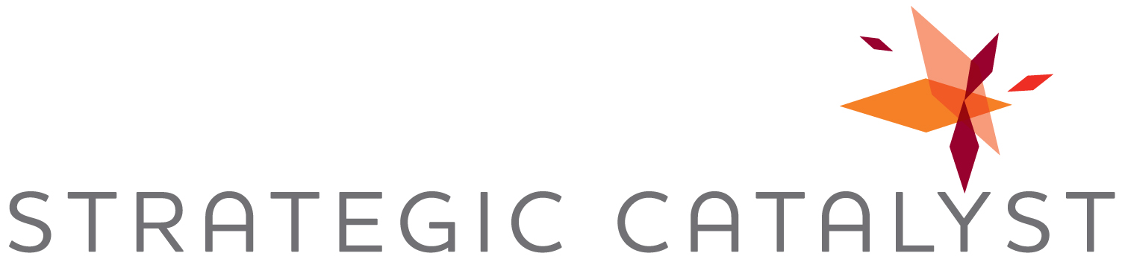

For Immediate Release
Contact:
Christine Spray
Strategic Catalyst, Inc.
832-380-8223
cspray@strategiccatalystinc.com

Business Growth Expert Christine Spray Collaborates with Steve Forbes on New Book: SuccessOnomics – Doing Business in Today’s Economy

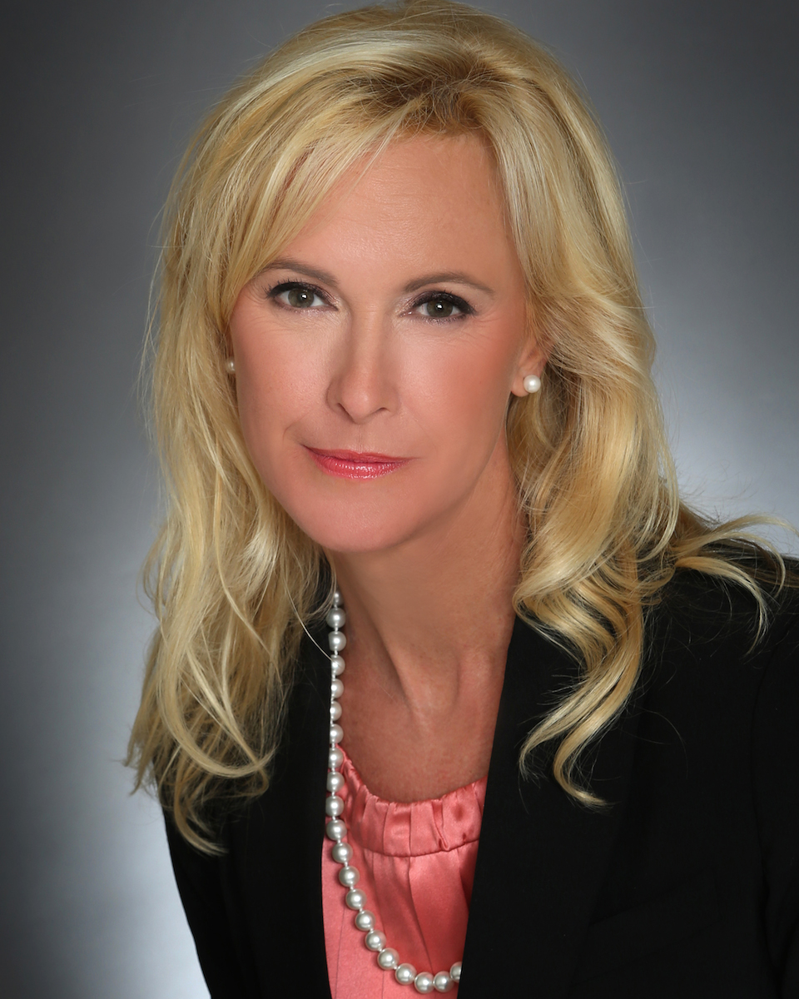
Houston, TX (April 7, 2014) – Christine Spray, Founder and President of Strategic Catalyst Inc and Founder and President of the National Business Development Association (NBDA) – a nationally recognized business development professional, trainer and coach – announced today the launch of her new book, SuccessOnomics. SuccessOnomics is a collaboration between various experts, professionals and entrepreneurs, including Steve Forbes, focusing on the concept of achieving goals through fiscal competence.

The book teaches the secrets of success in this new economy and it shares the various authors’ success methodology and mindset. Spray’s chapter 38 of the book focuses on ‘Building a Referral Pipeline” and provides insight about the importance of developing rapport and trust, creating a value proposition, effective networking and implementing a client review process, etc.

“It’s an honor and privilege to collaborate with so many esteemed experts for SuccessOnomics. Each of us is successful in different areas, which means we’ve been through both wins and losses, and have taken action to claim the term success for ourselves. And now, we’re sharing our methodology, best practices and mindset to guide and coach readers to success in their own lives,” said Spray.

Spray, a native Houstonian, launched Strategic Catalyst, Inc. after working in public accounting and industry in senior leadership roles with start-up, restructuring and growth responsibilities. She recognized that by aligning business goals with marketing, human resource and business development strategies, organizations could leverage new business opportunities for far greater results. With 20 years of experience, Spray has created proven programs for management in the area of new business strategy by implementing individual revenue assessments, business development programs, strategic business development plans, and accountability models.

In addition, Spray launched the National Business Development Association (NBDA) to fill the need for a national trade association to provide best practices to individuals whose primary responsibility is generating business for their organization. NBDA provides a vibrant learning community where members can stay on top of industry trends and continually hone their skills through targeted professional development. Members of NBDA strongly believe in order to be a successful business development professional, you must focus on others and their needs before focusing on yourself. You will find this philosophy at the center of everything that is taught at the NBDA.

Spray also serves as Chair and National Speaker for Vistage International, the world’s leading chief executive organization; its affiliates have more than 16,000 members in 16 countries. In her Vistage leadership role, she provides monthly professional development programs and one-on-one coaching for CEOs to help them become better leaders, make better decisions and therefore achieve better results.

SuccessOnomics is available at Amazon.com.

###

About Strategic Catalyst, Inc.
Houston-based Strategic Catalyst helps clients increase revenue through strategic growth programs, targeted talent placement and value-added public speaking, providing the expertise, tools and resources to foster business growth. Learn more at www.strategiccatalystinc.com or call 832-380-823.

