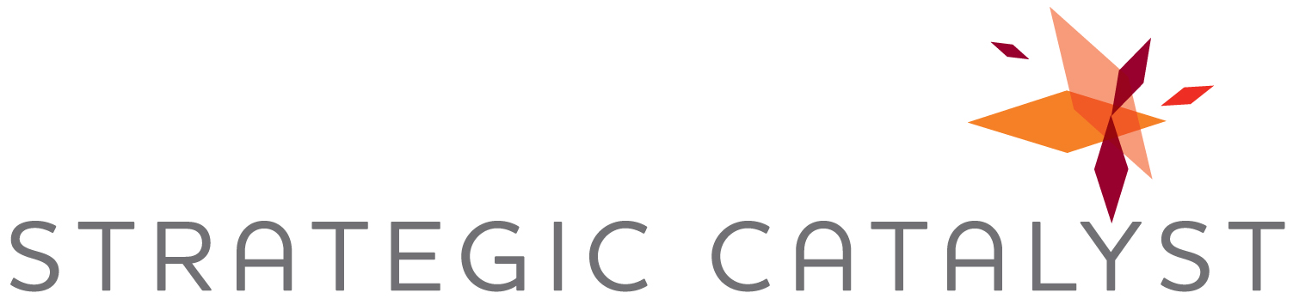

For Immediate Release
Contact:
Christine Spray
Strategic Catalyst, Inc.
832-380-8223
cspray@strategiccatalystinc.com

Business Growth Expert Christine Spray Signs Publishing Deal with CelebrityPress for New Book: Transform

Business development expert and national speaker, Christine Spray, will team with CelebrityPress, a leading book publishing company, and other leading experts from across the globe to release the new book, “Transform.”

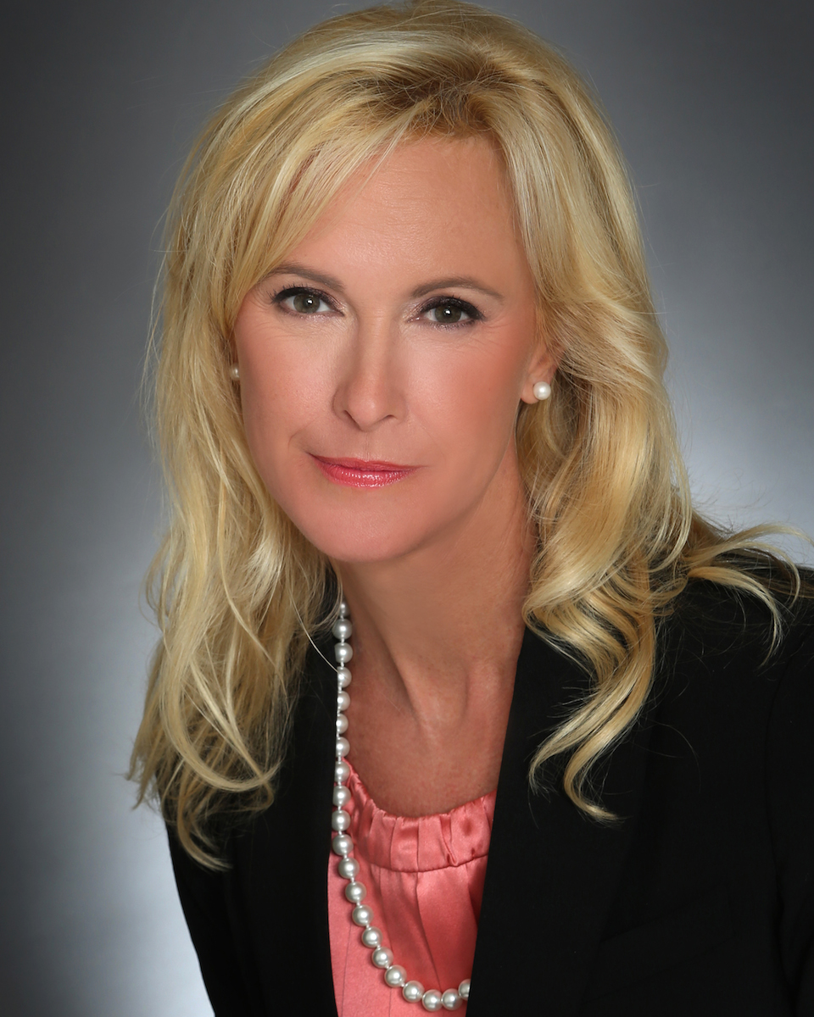
Houston, TX (June 13, 2014) – Best-selling author Christine Spray, Founder and President of Strategic Catalyst, Inc. and National Business Development Association, has joined noted business development expert, best-selling author and speaker, Brian Tracy, along with a select group of the world’s leading experts, to co-write the forthcoming book titled, Transform: The World's Leading Entrepreneurs and Professionals Get to the Heart and Soul of Transforming your Life, Business & Health. Nick Nanton, Esq., along with business partner, JW Dicks, Esq., recently signed a publishing deal with Christine and the other authors to contribute their expertise to the book, which will be released under their CelebrityPress™ imprint. Christine will contribute a chapter titled, “Choosing The Life You Desire.”

Christine Spray is a nationally-recognized business development keynote speaker, best-selling author, consultant, trainer and coach. Spray serves as a CEO and business advisor with a passion for helping people and companies grow. She has led numerous organizations’ efforts in new business development, strategic marketing, employee retention and professional development programs, client relations and operations.

CelebrityPress™ describes the book:

When we think of transformation, we automatically think of metamorphosis or change. One of the first metamorphoses we discover as a child is the universally- quoted change of the caterpillar into the butterfly. The positive symbolism of this transformation is liberally applied to illustrate the change from ‘ugly duckling’ to ‘elegant swan’ in all fields.

This symbolism readily transfers to just about any change for the better. The guidance of individuals who have experienced positive change with mentoring, have taken calculated risks and enjoyed accomplishments in their field, may be seen as role models. We also note that the transformations of the PremierExperts® in this book are not limited by ‘dollars and cents’ measurement, but include body, mind and soul accomplishments.

The transforming experiences discussed by the PremierExperts® in this book cover many subjects including positive mindset changes, changes wrought by perseverance, passion, due diligence, restructuring, technology, systems, techniques, etc., …in fact, they cover positive changes that cut across numerous disciplines and fields.

The book is tentatively scheduled for release in September 2014.

###

About Strategic Catalyst, Inc.
Houston-based Strategic Catalyst helps clients increase revenue through strategic growth programs, targeted talent placement and value-added public speaking, providing the expertise, tools and resources to foster business growth. Learn more at www.strategiccatalystinc.com or call 832-380-823.

About Celebrity Press™:
Celebrity Press™ is a leading business, health and wellness book publisher that publishes books from thought leaders around the world. Celebrity Press™ has published books alongside Jack Canfield, Brian Tracy, Dan Kennedy, Dr. Ivan Misner, Robert Allen and many of the biggest experts across diverse fields. CelebrityPress™ has helped launch over 1400 best-selling authors to date. Learn more at http://www.celebritypresspublishing.com

